AGGREGATING MULTIPLE DANGEROUS DEVICES

As with any Core Audio device, multiple I/O sources may be combined to form a large, virtual interface. In the case of two or more Dangerous Music CONVERT-series devices, this aggregation can be phase-locked due to special processes within the hardware that help ensure accurate timing. This document describes the most successful method to combine these interfaces together with phase accuracy.

Aggregation of any Core Audio compliant device in Apple’s OS X can be accomplished from the Audio MIDI Setup application. This application is located in \Applications\Utilities by default.

In this document, we will describe the aggregation of 2 CONVERT-8s, though the same steps can be applied to any combination of CONVERT-series devices. The resulting aggregate can be used in any DAW that is compatible with Core Audio.

- START WITH YOUR COMPUTER TURNED OFF. Next, attach the USB and AC cables to the CONVERTs. If possible, connect the USB cable directly into the computer. If two (or more) ports are not available, any good USB 2.0 or 3.0 hub can be used, as long as the units are plugged into the same hub and that hub is connected directly to the computer. Our favorite hub tested so far is a Sabrent 4 port USB 3.1 hub.

- Turn on your computer and power up the CONVERTs (and any other devices being aggregated).

- Set up your Word Clock according to the following rules:
  - WC must be distributed to the CONVERTs, either by looping the word clocks in a daisy-chain starting from one CONVERT (preferred, due to superior JetPLL clocking) or from an external word clock source.
  - The clock source on slaved unit(s) must be set to external (lit button).
  - If using a daisy chain, the first clock must be set to WC Master.

- Create your aggregate device as outlined in the AGGREGATION 101 document, selecting all devices that you would like to include. Remember to turn off DRIFT COMPENSATION in the Audio/MIDI Setup window and ensure that the correct clock source is selected as the aggregate’s clock source.

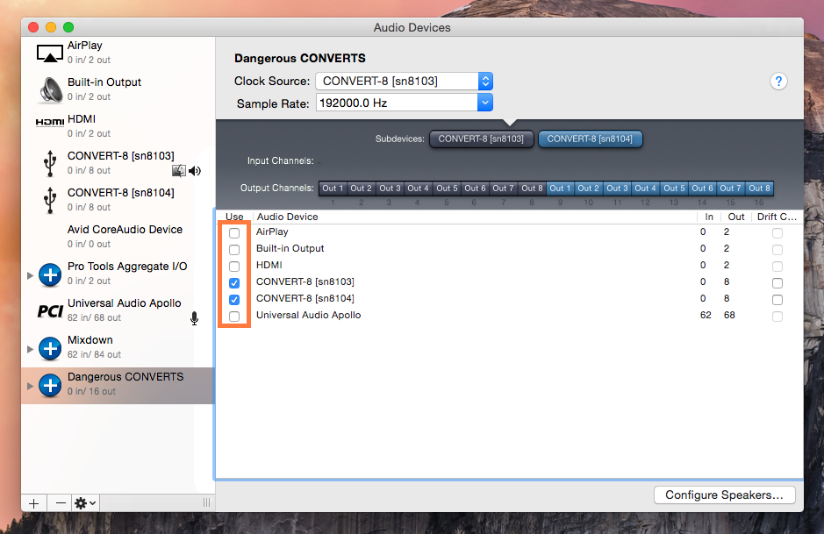

5. The aggregate device will now show up as an option in the device setup in your DAW. Select this and set up your I/O accordingly.

(see next page for troubleshooting tips)

TROUBLESHOOTING TIPS:

-Occasionally the audio stream will start inter-frame and will not lock. To try again: close the audio application, power-cycle both CONVERTs, and restart the audio stream.

-Sometimes, if one of the CONVERTs is selected by the audio application or the operating system when it starts instead of the aggregate group, a lock will not be achieved. This is because a blank (waiting) audio stream will begin to the selected CONVERT first. The audio stream must begin to both at the same time. To solve this, select the aggregate group and close the audio application. Then, power-cycle both CONVERTs and restart the audio application or operating system.

-Sometimes (usually while using driver-sharing DAWs like Cubase or Nuendo) closing the program (in order to retry a lock) will hand the aggregate group off to the operating system. This will continue to stream blank audio to the devices. This will prevent a retry of the lock. To solve this, restart the computer, power-cycle the CONVERTs and open the DAW. The driver should remain with the last selected (aggregate group) and the lock should succeed.

-note: if the lock does fail when starting up, an offset (a maximum of about 28 samples @ 192k) is possible. This offset will remain constant and will not drift over any amount of time. In most cases, this small offset is not noticeable, and will usually not cause undesired results. When in doubt, a complete power-cycle of the system will usually ensure a time-accurate lock.

